Build an Amazon VPC Using the VPC Wizard

Alen Ovalles

Purpose

The purpose of this lab is the introduction of elastic ip addresses and to build an Amazon Virtual Private Cloud (Amazon VPC) using the VPC Wizard in the VPC Management Console. To Troubleshoot problems that would hinder the process of completing the lab by brainstorming ideas of solutions.

Process with Pictures

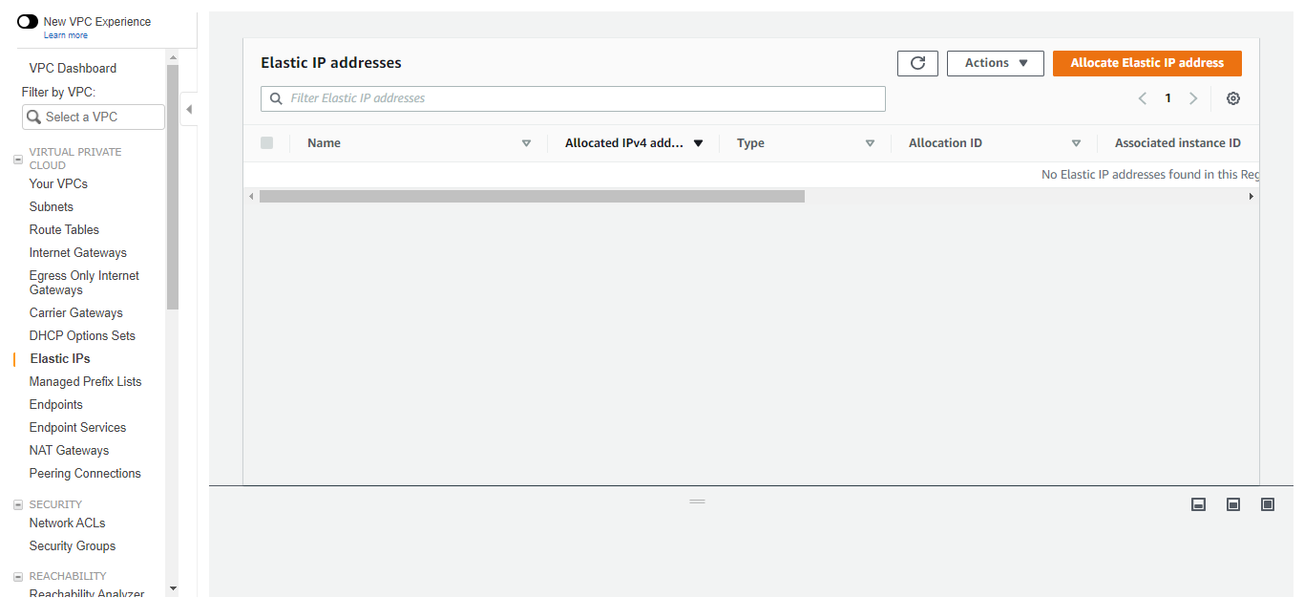

**Step 1:** Allocate an Elastic IP address; to use in place for the NAT Gateway

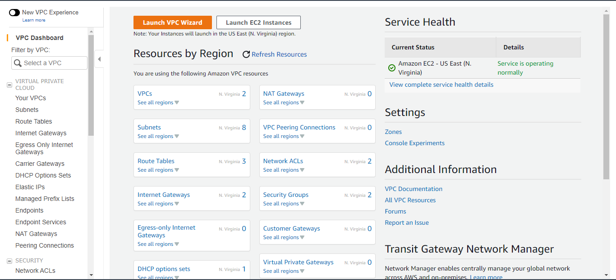

**Step 2:** Navigate to the VPC Dashboard and click on the “Launch VPC Wizard”

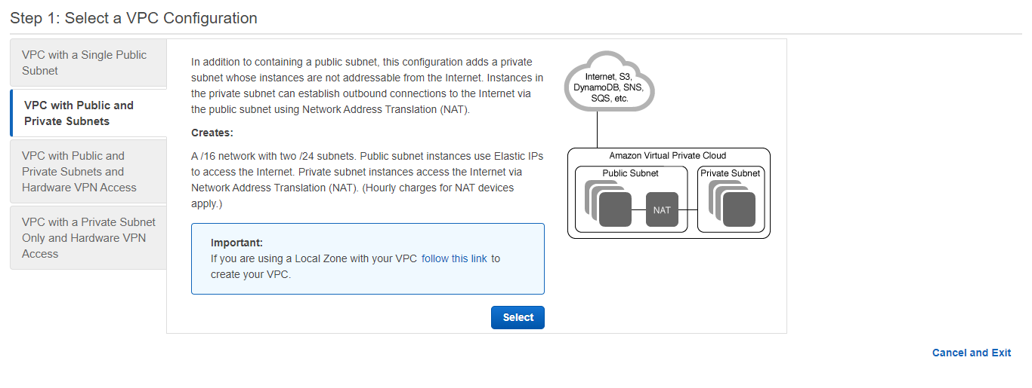**Step 3:** Select the VPC configuration of “VPC with Public and Private Subnets”

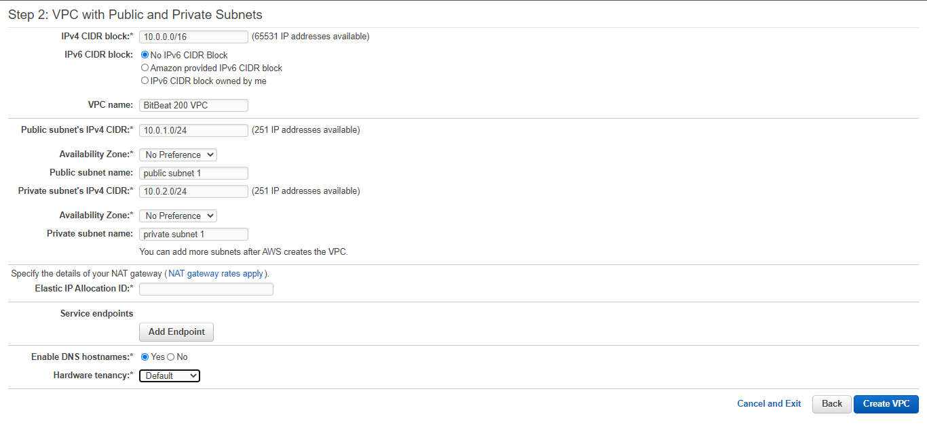

**Step 4:** Enter the following; Name: BitBeat 200 VPC | Public: Public subnet 1 (10.0.1.0/24) | Private: Private subnet 1 (10.0.2.0/24)

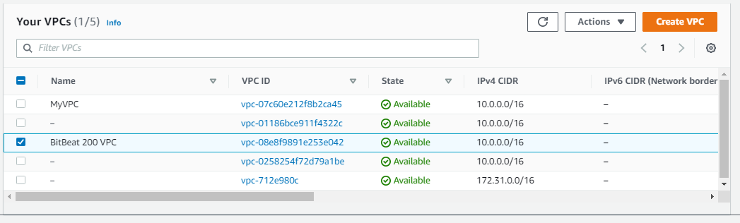

**Step 5:** Highlight create VPC and check that there are a VPC ID and main route table; Copy down the VPC ID and main route table for later use

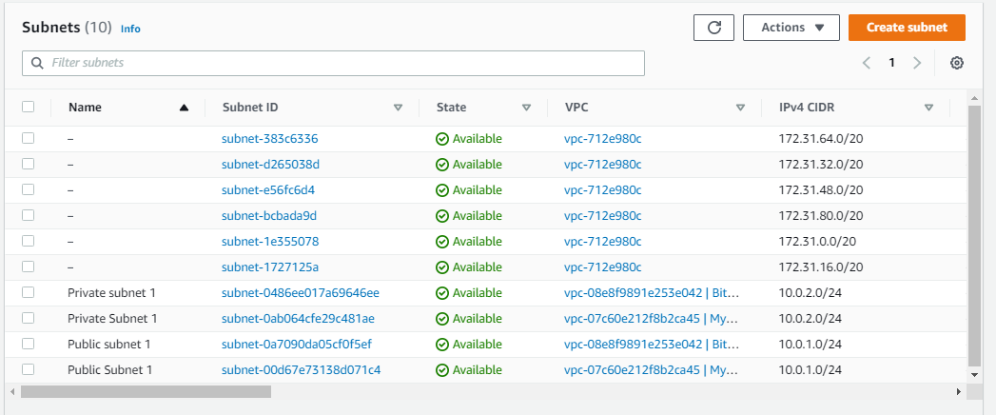

**Step 6:** Check the subnet table and under the corresponding VPC ID of “vpc-08e8f9891e253e042”| The lowercase “subnet 1” is the created VPC public and private subnets

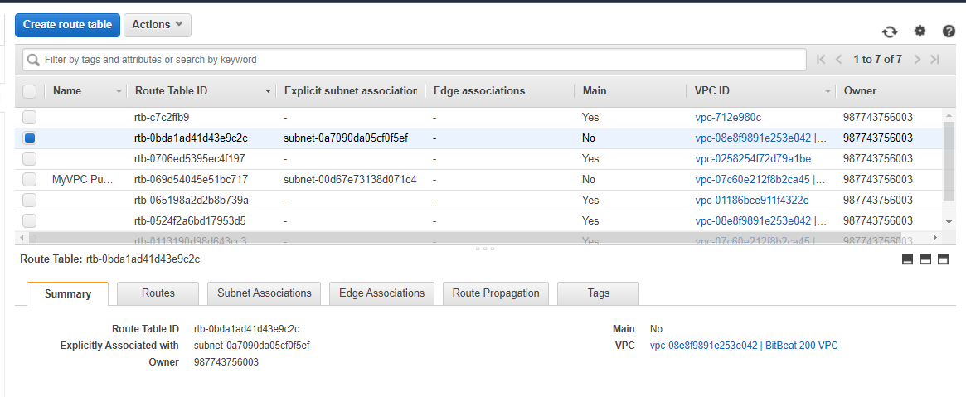**Step 7:** Check under the routing table to see the created VPC connection with its corresponding VPC ID of  **“**rtb-0524f2a6bd17953d5”

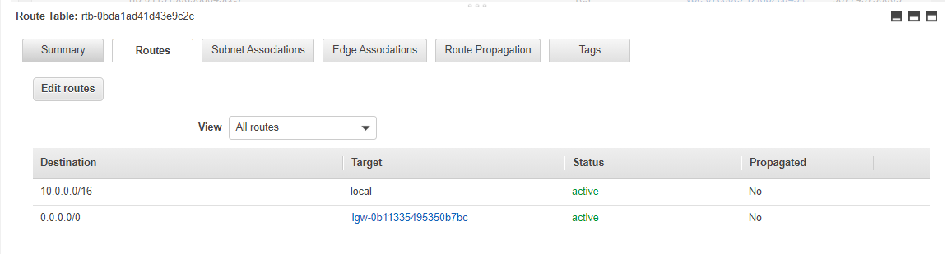**Step 8:** Check routing table; Notice the 0.0.0.0/0 value for destination

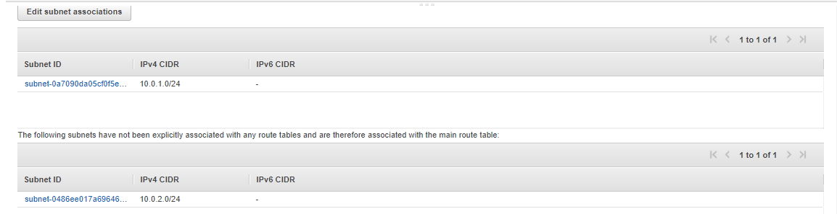**Step 9:** Check for the public and private subnets are in the routing table

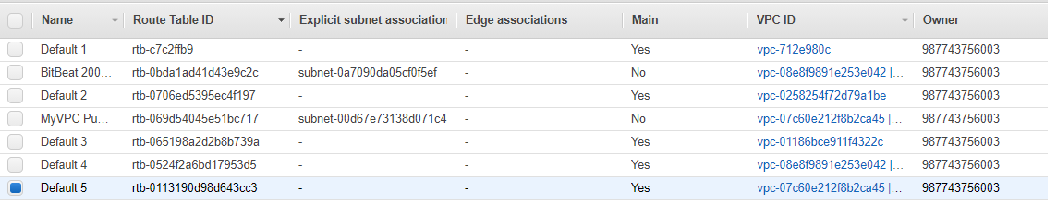**Step 10:** Add a name to all of the existing routes in the routing table

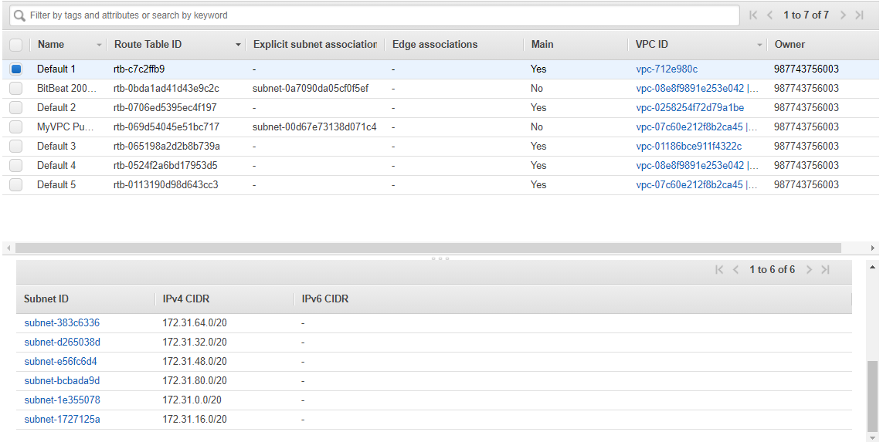**Step 11:** Click on the first Default route, examine the subnet IDs and corresponding IP addresses

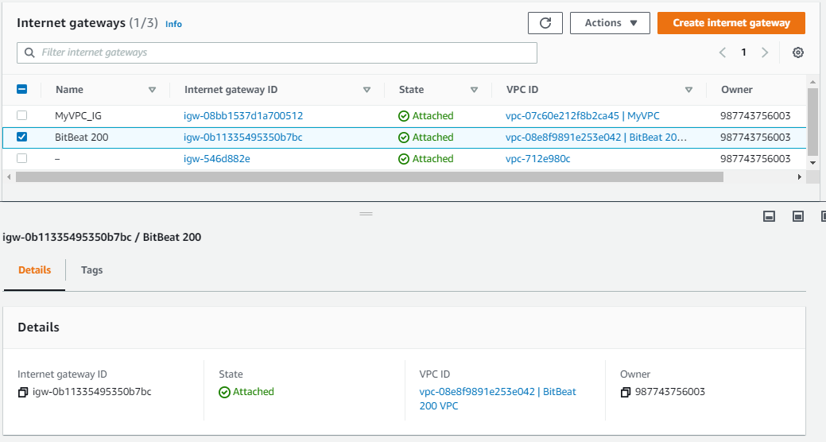**Step 12:** Highlighting the BitBeat 200 VPC and notice that the state of it is attached; To detach click Action > Detach from VPC

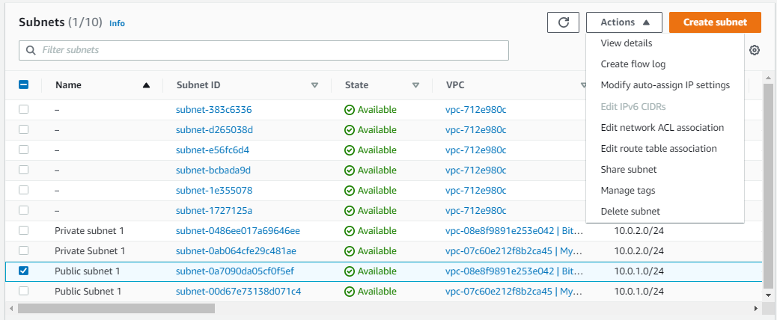**Step 13:** Highlight the public subnet and click on Actions button then Modify auto-assign IP settings

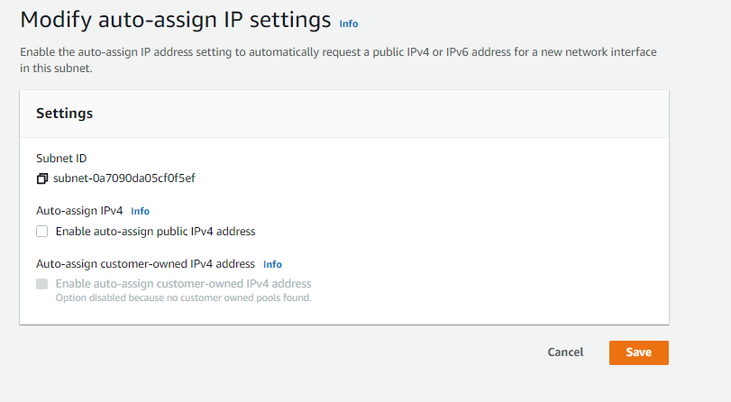

**Step 14:** Don’t save auto-assign, just make a mental note that this exists

Problems

One problem that was a big one is with adding a NAT Gateway instance on the create VPC. The fix was found to have to borrow an elastic ip address from Amazon, allowing access to the next steps of the lab and creating the Nat Gateway. A minor problem was when ending the lab and releasing the elastic ip address. I found out that the elastic ip address couldn’t be released when going to Action > Release Elastic IP Address. The solution was to delete the NAT Gateway first by going to the NAT Gateway Tag on the side of the VPC Dashboard and delete the NAT Gateway there.